UNIVERSITY OF TECHNOLOGY
FALCULTY OF COMPUTER SCIENCE AND ENGINEERING

Test plan for “Công cụ tạo đề thi trắc nghiệm”
-Software Testing-
Group 4:

Test leader :
Đỗ Xuân Chung 50600212

Tester :
            - Đỗ Xuân Chung 50600212
            - Nguyễn Thái Vân Long 50601330
            - Phạm Đức Long 50601344
            - Trịnh Xuân Khoa 50601143
INDEX
- OVERVIEW
- Product name
- Product revision
- Project lead
- Test project staff
- Product overview
- TEST PLAN OBJECTIVE
- TESTING STRATEGY
- System test
- Performance test
- Stress and volume test
- Recovery test
- Documentation test
- Installation test
General testing process approach
- Items to be tested
- Items not to be tested
- HARDWARE / SOFTWARE RESOURCES
- Hardware requirements
- Software requirements
- Reference material
- TYPE OF TESTING
- Feature test
- Features to be tested
- Features not to be tested
- Installation test
- RISKS AND CONTINGENCIES
- SUSPENSION CRITERIA AND RESUMPTION REQUIREMENTS
- TEST SCHEDULE AND RESOURCES
- Test schedule
- Resources
- ROLES AND RESPONSIBILITIES
- DELIVERABLES

- OVERVIEW
  - PRODUCT NAME
“CÔNG CỤ TẠO ĐỀ THI TRẮC NGHIỆM”
  - PRODUCT REVISION
Last vision.
  - PROJECT LEAD
    - Đỗ Xuân Chung - 50600212
  - TEST PROJECT STAFF
    - Đỗ Xuân Chung - 50600212
    - Nguyễn Thái Vân Long - 50601330
    - Phạm Đức Long - 50601344
    - Trịnh Xuân Khoa - 50601143
  - PRODUCT OVERVIEW
Program ‘s functions :
    - Store and display document with image and formula format.
    - Good “questions bank” management.
    - Good ‘question exam bank” management.
    - Out put is in Microsoft word format. .
- TEST PLAN OBJECTIVE
This Test Plan for the tool for “Công cụ tạo đề thi trắc nhiệm” supports the following objectives:
- Identify the strategies that will be used to verify and ensure the product meets its desired specifications and other requirements.
- Define the objectives and scope for the testing effort.
- Identify the methodology that test team will use to conduct tests.
- Identify the hardware, software and tools required for testing.
- Define functions and features that will be tested.
- Determined risk factor that jeopardize testing
- Schedule for testing with the specific assignment for each members.

- TESTING STRATEGY
The test strategy consists of a series of different tests that will fully exercise the visualizing application. The primary purpose of these tests is to uncover the systems limitations and measure its full capabilities. A list of the various planned tests and a brief explanation follows below.

System Test
The System tests will focus on the behavior of the visualizing system. User scenarios will be executed against the system as well as screen interacting and error message testing. Overall, the system tests will test the integrated system and verify that it meets the requirements defined in the requirements document.
- Performance Test
Performance test will be conducted to ensure that the visualizing system’s response time meet the user expectations and does not exceed the specified performance criteria. During these tests, response times will be measured under heavy stress and/or volume.
- Stress and Volume Test
We will subject the payroll system to high input conditions and a high volume of data during the peak times.
- Recovery Test
Recovery tests will force the system to fail in a various ways and verify the recovery is properly performed. It is vitally important that all data is recovered after a system failure & no corruption of the data occurred.
- Documentation Test
Tests will be conducted to check the accuracy of the output Microsoft word documentation. These tests will ensure that no features are missing, and the contents can be easily understood.
- Installation Test
The application will be installed on some environments (Windows XP SP2, SP3 and Windows Vista) and we will check its compatibility with those environments. In the other hand, we will test the process of removing the application from the system.

General Testing Process Approach
- Review project document.
- Design test strategy and Determine test requirements.
- Create test plan.
- Design test case template.
- Design and build test case.
- Execute test plan.
- Create test report.
  - Items to be tested
    - “Soạn câu hỏi” function.
    - “Sinh đề thi” function.
    - “Quản lý kỳ thi/Bộ đề” function.
  - Items not to be Tested
    - “Quản lý môn học / Chương mục” function.
    - Copyright, license.
- HARDWARE / SOFTWARE RESOURCES
  - Hardware Requirements
    - CPU >= 1.0 GHz
    - RAM >= 256 MB
    - Hard Disk Space available >= 50 MB
    - Graphic Card with Memory size >= 64MB
    - Internet Connected
  - Software Requirements
    - Windows XP SP2.
    - Windows XP SP.
    - Windows Vista..
    - Current Windows version is able to update.
    - Microsoft SQL Server 2005
    - Microsoft Visual Studio 2005
    - .NET Frameworks 2.0 or later.
  - Standards/Reference material
    - http://www.cse.hcmut.edu.vn/~minhnnn/File/Document/ST/Assignment/Assignment.pdf
- TYPES OF TESTING
  - FEATURE TEST
    - Features to be tested:
      - “Soạn câu hỏi”function:
- Create new question.
- Edit existing question.
- Delete existing question.
- Create new group of question.
- Edit new group of question.
- Delete new group of question.
- Stop creating new question.
(Repeat each test case with text, image, formula format)
      - “Sinh đề thi”function:
- Create new exam question
- Delete existing exam question
- Automatically create new exam question
- Delete existing question in exam question
- Update order of question in exam question
- View exam question ‘s solution
- Delete all questions in exam question
- Automatically create exam question.
- Manually create exam question
      - “Quản lý kỳ thi / bộ đề”function
- Create new examination
- Delete existing examination
- Mix all questions in “question book”
- Add question to “question book”.
- To export Microsoft Word document.

    - Features not to be tested:
      - Application building
      - Stop running application
      - Vietnamese support
      - Copyright, license
  - INSTALLATION TEST
    - Build program while current Windows is updating.
    - Redo all test case in Futures testing while Windows is updating.
- RISKS AND CONTINGENCIES
STT | Risk | Contingency plan
1 | Requirement changes affect to human resources and test strategy | Re-edit test plan to meet new requirements
2 | Application is not able to be built on time | Re-build in other PCs and testing team must follow the schedule strictly
3 | Virus effectively | Highlight this to every one in team, update newest version for anti virus program
4 | Executed test case lost | Hand in executed testcase report / document to team leader by the end of day via e-mail

- SUSPENSION CRITERIA AND RESUMPTION REQUIREMENTS
Suspension criteria:
- Hardware/software is not available at the times indicated in the project schedule.
- Source code contains one or more critical defects, which seriously prevents or limits testing progress.
- Assigned test resources are not available when needed by the test team.

Resumption Requirements:
If testing is suspended, resumption will only occur when the problem(s) that caused the suspension has been resolved. When a critical defect is the cause of the suspension, the “FIX” must be verified by the test department before testing is resumed.

- TEST SCHEDULE AND RESOURCES
  - Test schedule:
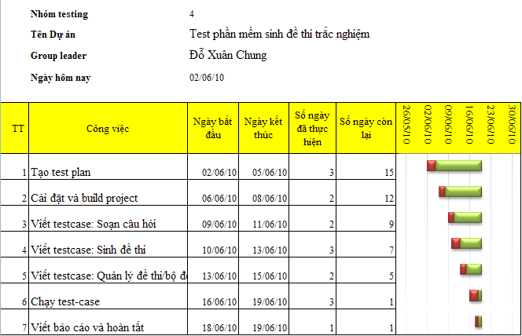
  - Resources:
The test team will consist of:
- A Test Leader
- 4 Testers

- ROLES AND RESPONSIBILITIES
Worker | Minimum Resources Recommended | Specific Responsibilities / Comments
Test leader  Đỗ Xuân chung | 30% | Provides management oversight  Responsibilities:  - Provide Technical direction  - Acquire appropriate resources  - Management reporting  - Ensure test environment and assets are managed and mantained.
Test Designer  Đỗ Xuân Chung  Phạm Đức Long  Nguyễn Thái Vân Long  Trịnh Xuân Khoa | 30%  50%  50%  50% | Identifies, prioritizes, and implement test cases  Responsibilities:  - Generate test case  - Evaluate effectiveness of test effort  - Prepare test data
Tester  Đỗ Xuân Chung  Phạm Đức Long  Nguyễn Thái Vân Long  Trịnh Xuân Khoa | 40%  50%  50%  50% | Execute the tests  Responsibilities:  - Execute tests  - Log results  - Recover from errors  - Document defects

- DELIVERABLES
Deliverable | Responsibility | Completion Date
Develop Test cases | Testers | 15/06/10
Test Case Review | Test Leader, Testers | 16/06/10
Execute manual | Test Leader, Testers | 19/06/10
Complete Defect Reports | Test Leader, Testers | 19/06/10

